CG6-CHAS-E-019 Test Fixture Instructions
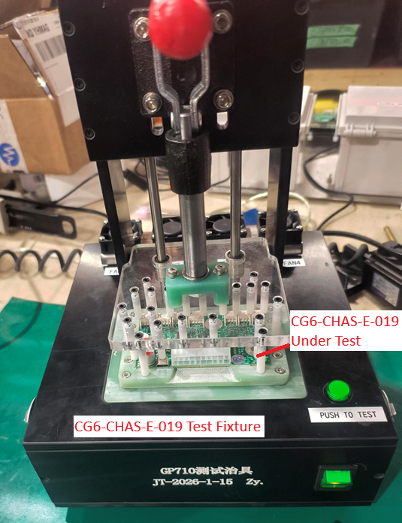
Contents
Operating Instructions 2
Remote Updates and Troubleshooting 5

Operating Instructions
Requires:
CG6-CHAS-E-019 Test Fixture, CG6-CHAS-E-019 v1.5+ PCBAs and HDMI monitor
Step 1
Connect power cable to rear of test fixture
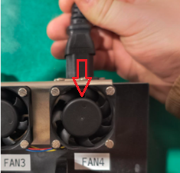
Step 2
Connect HDMI cable from monitor to test fixture
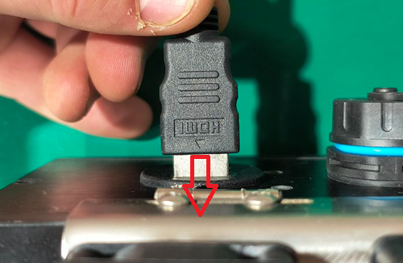
Step 3
Place the power switch in the ON (I) position
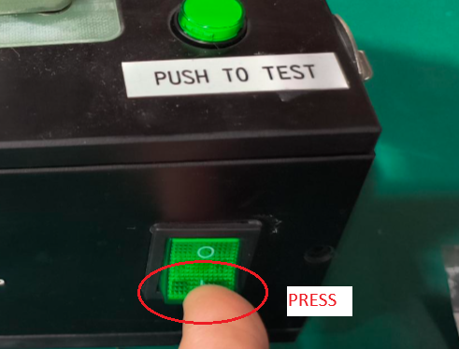
Step 4
Wait for approximately one minute while the computer inside the test fixture boots and launches the testing program. Note the output on the monitor. Note the software version at the top of the screen and the INFO instructions
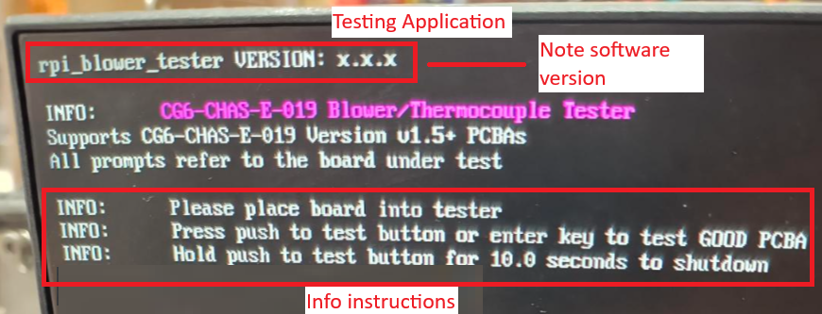
Step 5
Place a GOOD reference board into the test fixture and pull the plunger down. A GOOD reference board is a PCBA that previously passed in the test fixture
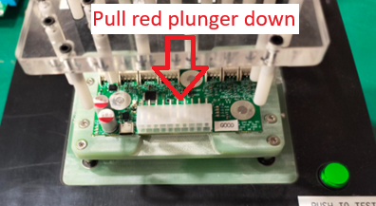
Step 6
Press the PUSH TO TEST button to start the test
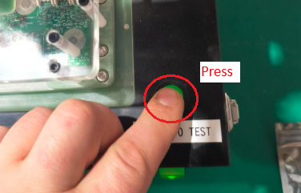
Step 7
Note the test output on the monitor. If the overall test result for the GOOD reference board is FAIL, contact Gastronomous. Testing takes approximately one minute
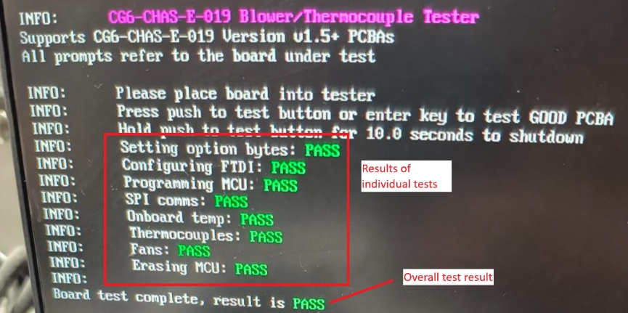
Step 8
When the test is complete, release the plunger and unload the GOOD reference board. Continue to test the remainder of the CG6-CHAS-E-019 boards from current production. If the PCBA fails, troubleshooting information and designators will be displayed to the monitor
Step 9
When testing is complete, hold the PUSH TO TEST for 10 seconds to safely shut down the computer inside the test fixture. The monitor will instruct when to release the button to start the safe shutdown
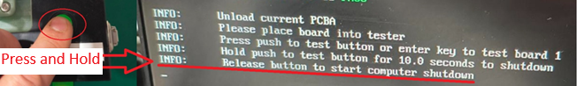
Step 10
After monitor is blank, set the power switch to the OFF (O) position
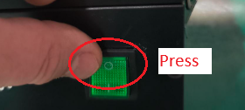

Remote Updates and Troubleshooting
Requires:
CG6-CHAS-E-019 test fixture, GOOD CG6-CHAS-E-019 v1.5+ PCBA, ethernet cable and internet connection
Step 1
Place the GOOD CG6-CHAS-E-019 into the test fixture and pull the plunger down
Step 2
Unscrew the cover on the ethernet bulkhead on the back of the test fixture and connect to the internet with an ethernet cable
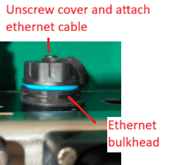
Step 3
Keep the test fixture powered on and notify the Gastronomous Team over WeChat

